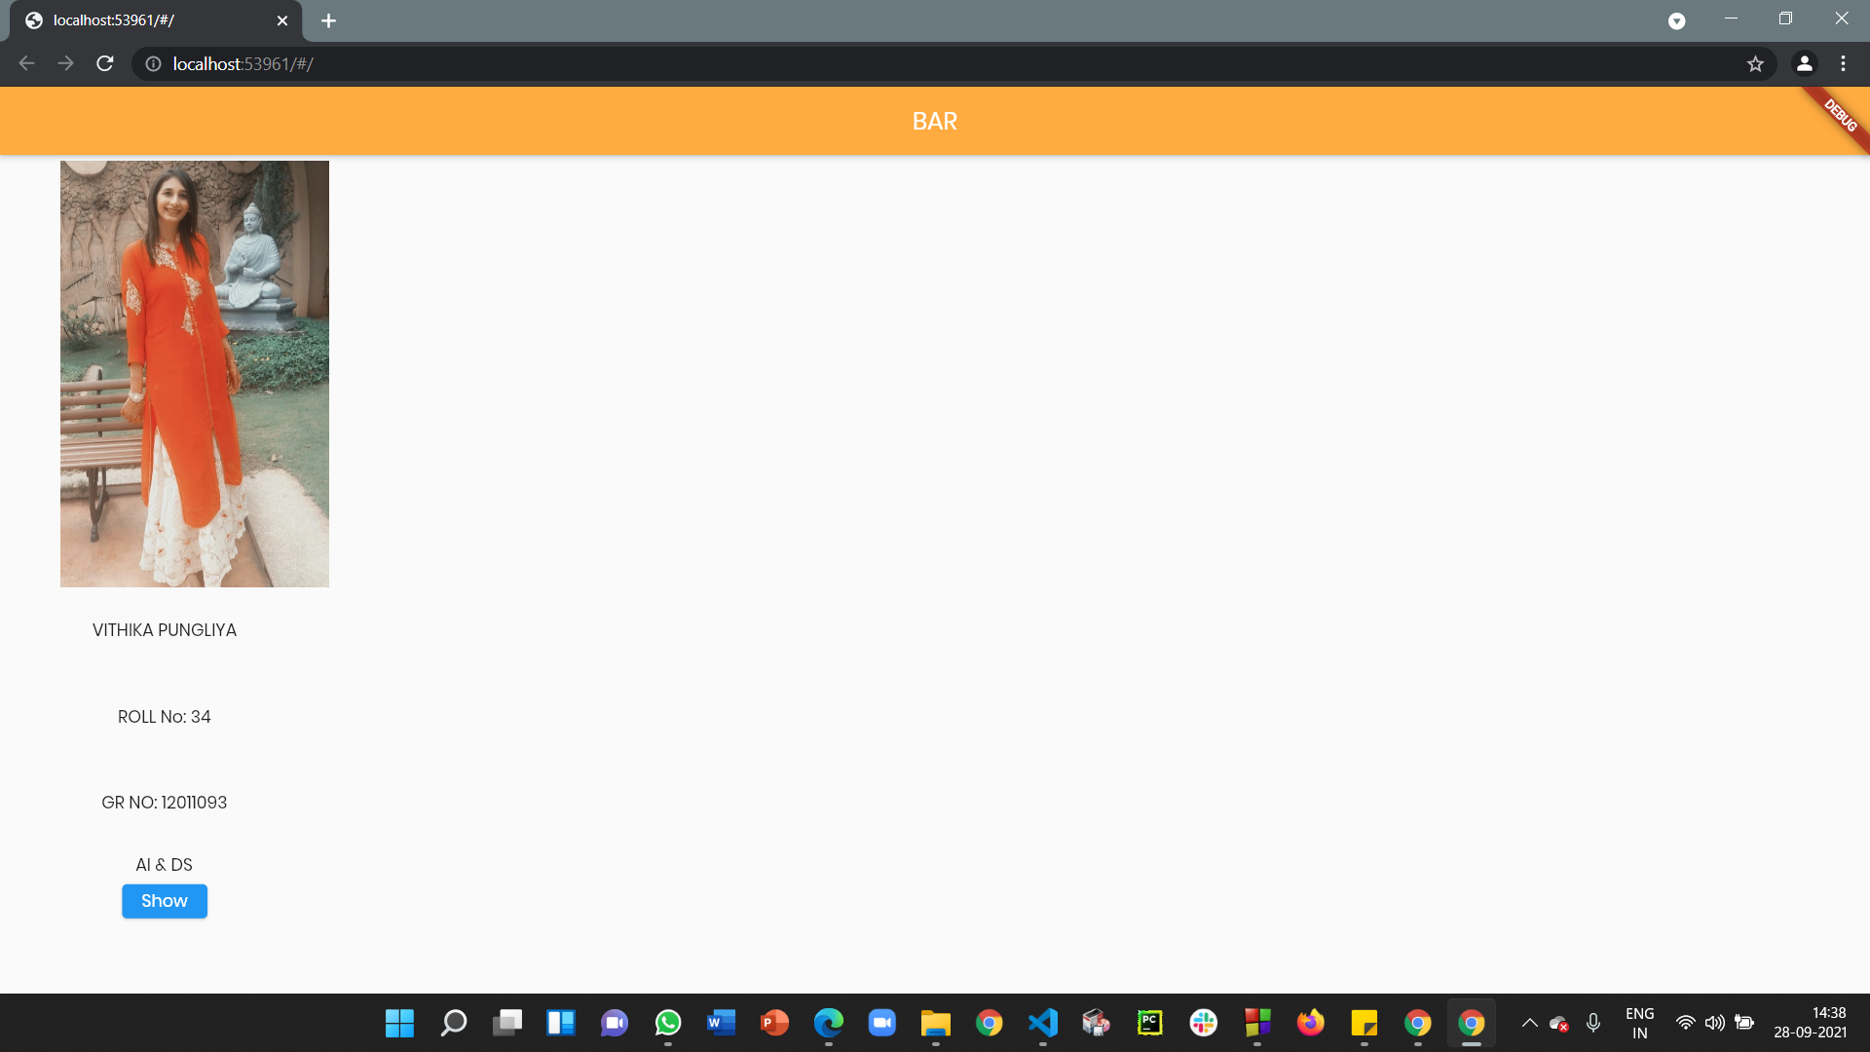

TASK 8

SCREENSHOT